Setting up Spark with Maven
Apr 2, 2015 • Written by David Åse • Spark Framework Tutorials
https://sparktutorials.github.io/2015/04/02/setting-up-a-spark-project-with-maven.html#eclipse

IDE Guides
- Instructions for IntelliJ IDEA
- Instructions for Eclipse

About Maven
Maven is a build automation tool used primarily for Java projects. It addresses two aspects of building software: First, it describes how software is built, and second, it describes its dependencies.
Maven projects are configured using a Project Object Model, which is stored in a pom.xml-file.
Here’s a minimal example:
<project>
<!-- model version - always 4.0.0 for Maven 2.x POMs -->
<modelVersion>4.0.0</modelVersion>

<!-- project coordinates - values which uniquely identify this project -->
<groupId>com.mycompany.app</groupId>
<artifactId>my-app</artifactId>
<version>1.0</version>

<!-- library dependencies -->
<dependencies>
<dependency>
<groupId>com.sparkjava</groupId>
<artifactId>spark-core</artifactId>
<version>2.2</version>
</dependency>
</dependencies>
</project>

Instructions for IntelliJ IDEA
Click “File” and select “New project…”: 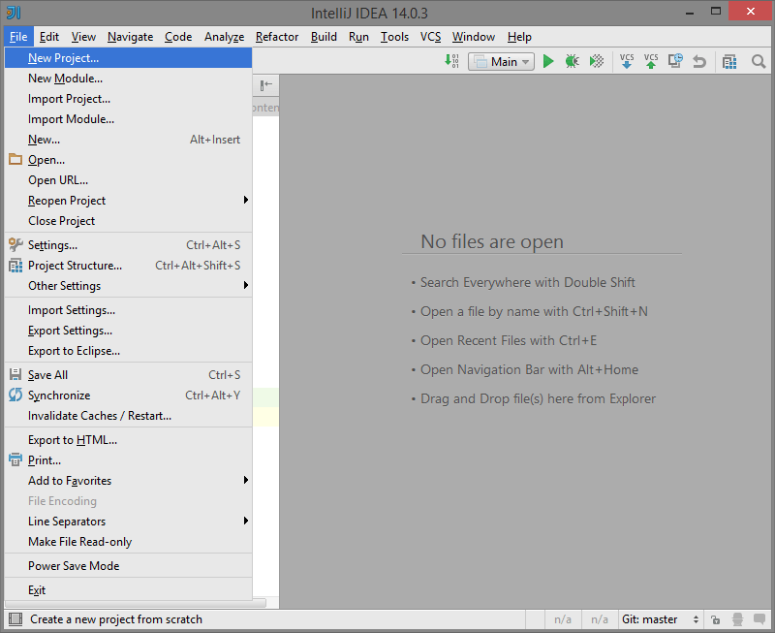
Select “Maven” on the left hand menu and click “Next”: 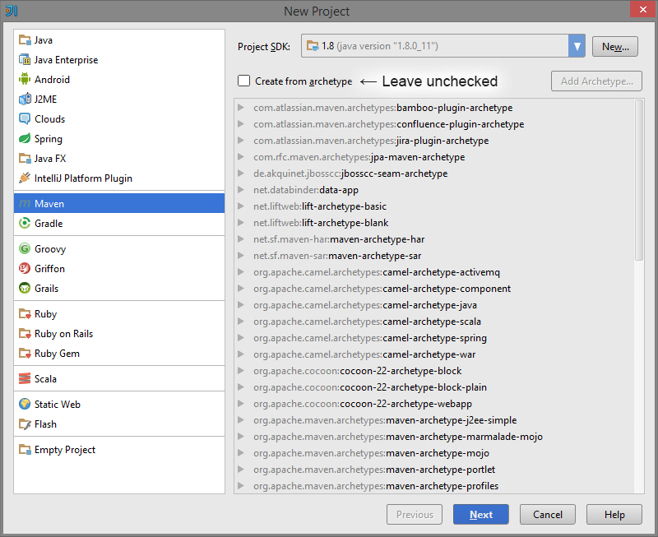
Enter GroupId, ArtifactId and Verison, and click “Next”: 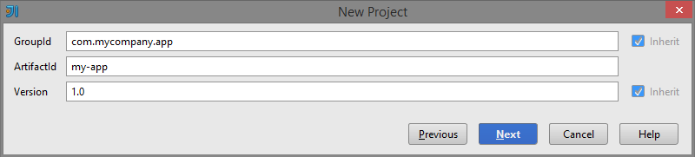
Give your project a name and click “Finish”: 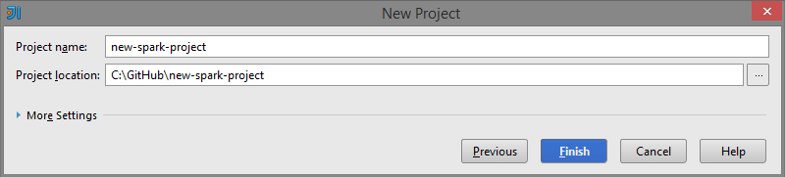
Paste the Spark dependency into the generated pom.xml. If prompted, tell IntelliJ to enable auto-import. 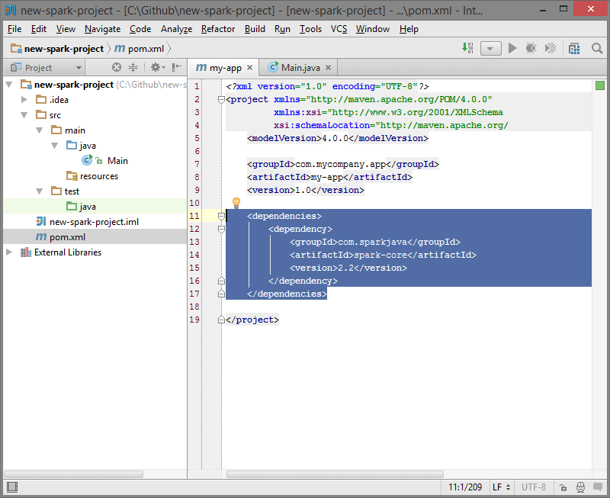

<dependencies>
<dependency>
<groupId>com.sparkjava</groupId>
<artifactId>spark-core</artifactId>
<version>2.2</version>
</dependency>
</dependencies>
Finally, paste the Spark “Hello World” snippet:
import static spark.Spark.*;

public class Main {
public static void main(String[] args) {
get("/hello", (req, res) -> "Hello World");
}
}
Into a new Class, “Main.java”: 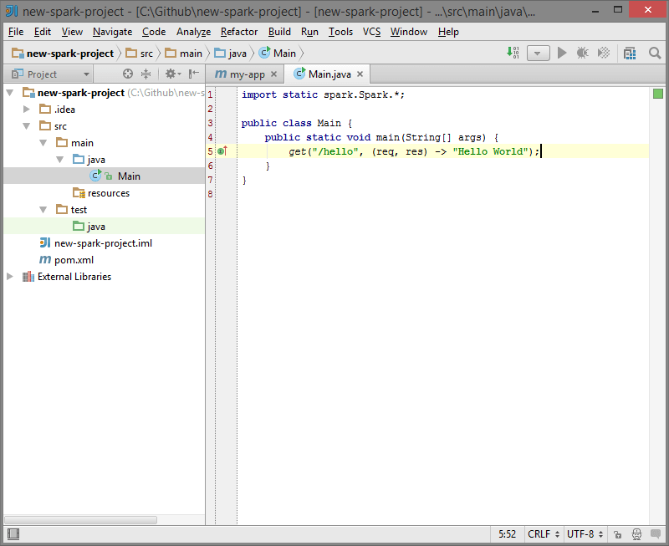
Now everything is ready for you to run your main Class. Enjoy!
If IntelliJ says "Method references are not supported at this language level",
press alt+enter and choose "Set language level to 8 - Lambdas, type annotations, etc.".

Instructions for Eclipse
Click “File” and select “New” then “Other…”: 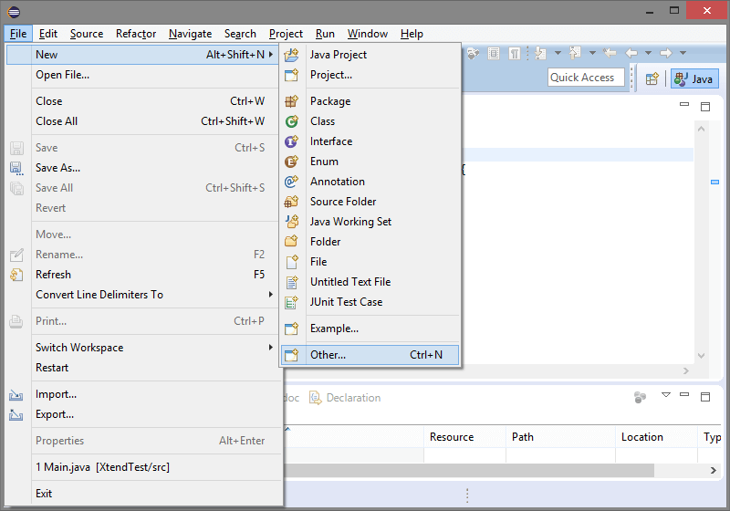
Expand “Maven” and select “Maven Project”, then click “Next”: 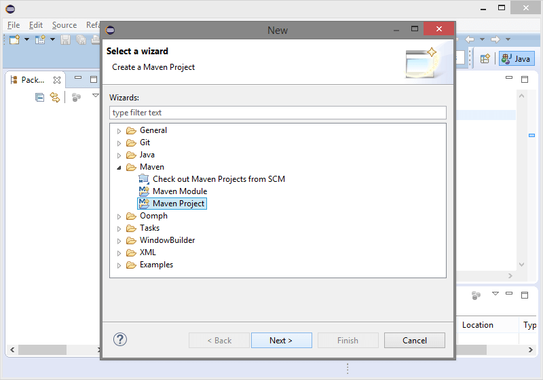
Check the “Create a simple project” checkbox and click “Next”: 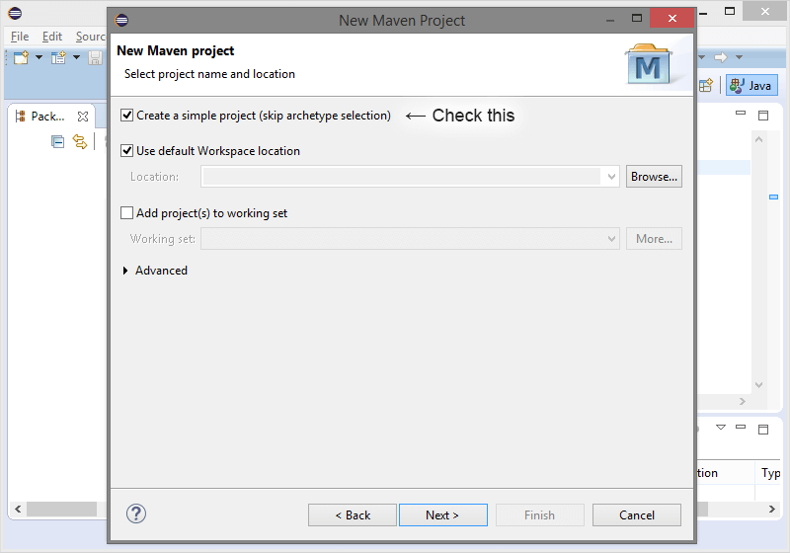
Enter GroupId, ArtifactId, Verison, and Name, and click “Finish”: 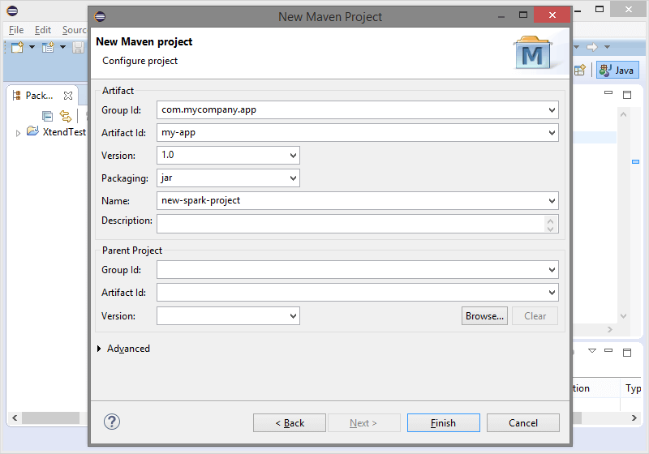
Open the pom.xml file and click the “pom.xml” tab. Paste in the Spark dependency: 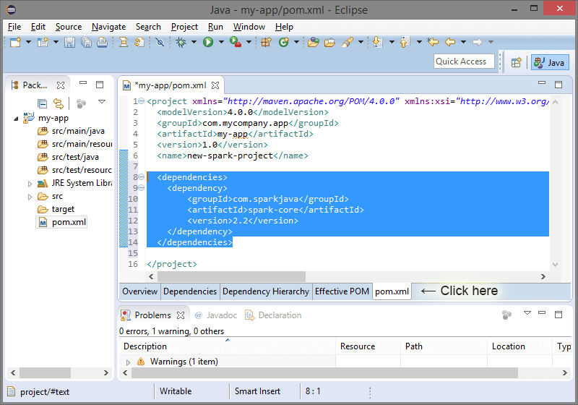
<dependencies>
<dependency>
<groupId>com.sparkjava</groupId>
<artifactId>spark-core</artifactId>
<version>2.2</version>
</dependency>
</dependencies>
Save the pom.xml file!
Finally, paste the Spark “Hello World” snippet:
import static spark.Spark.*;

public class Main {
public static void main(String[] args) {
get("/hello", (req, res) -> "Hello World");
}
}
Into a new Class, “Main.java”: 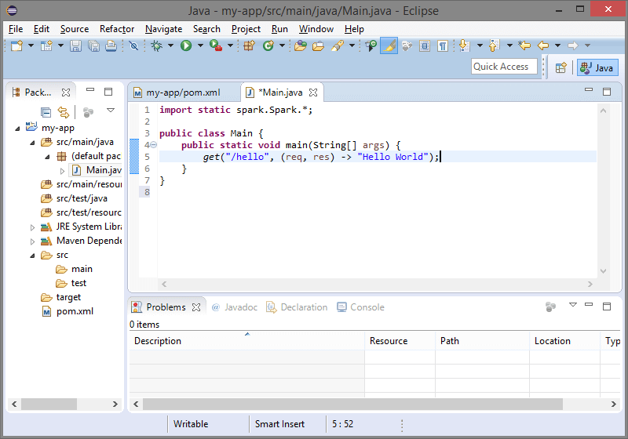
Now everything is ready for you to run your main Class. Enjoy!

